ADAPTIVE RETRIEVAL-AUGMENTED GENERATION SYSTEM WITH KNOWLEDGE GAP DETECTION FOR MEDICAL INFORMATION RETRIEVAL

A Dissertation submitted in partial fulfillment of the requirements for the degree
Of
INTEGRATED MASTER IN SCIENCE
IN
DATA SCIENCE
by
Mr. VAIBHAV S
CB.PS.I5DAS22056



DEPARTMENT OF MATHEMATICS
AMRITA SCHOOL OF PHYSICAL SCIENCES
AMRITA VISHWA VIDYAPEETHAM
COIMBATORE – 641112 (INDIA)
MARCH 2026

AMRITA SCHOOL OF PHYSICAL SCIENCES
AMRITA VISHWA VIDYAPEETHAM


BONAFIDE CERTIFICATE
This is to certify that the dissertation entitled “ADAPTIVE RETRIEVAL-AUGMENTED GENERATION SYSTEM WITH KNOWLEDGE GAP DETECTION FOR MEDICAL INFORMATION RETRIEVAL” submitted by Mr. VAIBHAV S (Reg. No.: CB.PS.I5DAS22056), for the award of the Degree of Integrated Master of Science in Data Science is a bonafide record of the work carried out by him at the Department of Mathematics, Amrita School of Physical Science, Coimbatore.

Signature of the Project Advisors Signature of the Project Coordinator

Signature of the Chairperson

AMRITA SCHOOL OF PHYSICAL SCIENCES
AMRITA VISHWA VIDYAPEETHAM
COIMBATORE 641112
DEPARTMENT OF MATHEMATICS

DECLARATION

I, Mr. Vaibhav S (Reg. No.: CB.PS.I5DAS22056), hereby declare that this dissertation entitled “Adaptive Retrieval Augmented Generation System With Knowledge Gap Detection For Medical Information Retrieval”, is the record of the original work done by me at Department of Mathematics, Amrita School of Physical Sciences, Amrita Vishwa Vidyapeetham, Coimbatore. To the best of my knowledge this work has not formed the basis for the award of any degree/diploma/ associateship/fellowship/or a similar award to any candidate in any University.

Place: Coimbatore Signature of the Student
Date:
COUNTERSIGNED
Dr. Sangeeta Kumari
Project Coordinator
Department of Mathematics
Contents

Acknowledgement 6
List of Figures 7
List of Symbols and Abbreviation 8
Abstract 9
- Introduction 10
  - Background
  - Problem Statement
  - Motivation
  - Proposed Approach and Overview
  - Objectives
  - Novel Contributions
  - Scope of the Work
- Related Works 14
- Dataset 15
- Preprocessing 16
  - Overview
  - Text Cleaning
  - Tokenization and Text Cleaning
  - Chunking Structuring
- Proposed methodology 19
  - Overview
  - Knowledge Base Construction
  - Embedding Generation
  - Vector Database Indexing (FAISS)
  - Retrieval Using Cosine Similarity
  - Gap Aware Evidence Scoring
  - Gap Detection
  - Response Generation Using LLM
- Experimental Results 26
6.1 Threshold Analysis and Knowledge Gap Detection
6.2 Outputs
7 Conclusion 31
References 32
Acknowledgement

I sincerely express my gratitude to the Department of Mathematics, Amrita Vishwa Vidyapeetham, Coimbatore, for their constant encouragement, thoughtful feedback, and patient guidance throughout every stage of this project. Their direction helped shape a scattered collection of ideas into a coherent, working system.
I express my sincere thanks to Dr. K. Somasundaram, Chairperson, Department of Mathematics, Amrita School of Physical Sciences, for his encouragement and providing necessary facilities in the Department.
I especially thank my Class Advisor Dr. Sangeeta Kumari for the generous support and care throughout my course of study.
I am also grateful to the faculty members of the Department of Mathematics whose coursework built the theoretical foundation this project stands on. I acknowledge my deep sense of gratitude and dedicate this work to my family members and friends who have always been a source of inspiration to me throughout my study. I am so grateful for their patience, love and care they have shown during the period of my project work.

(Vaibhav S)

List of Figures
3.1 Dataset Overview
3.1.1 Number of chunks per Textbook
4.4 Chunking example
5.1 Overall Architecture
6.1 Threshold selection for the knowledge gap detection showing the variation of accuracy precision recall and F1-score across different threshold values
6.2 Output for Medical Domain Question
6.2.1 Output for Non-Medical domain Question

List of Symbols and Abbreviation

RAG Retrieval Augmented Generation
LLM Large Language Model
FAISS Facebook AI Similarity Search
NLP Natural Language Processing
AI Artificial Intelligence
GAP Knowledge Gap (Insufficient Evidence)
NO GAP Sufficient Evidence Available
Top-k Top number of most relevant retrieved chunks
CSV Comma Separated Values
A Query embedding vector
B Chunk embedding vector
A ⋅ B Dot product of two vectors
||A|| Magnitude (norm) of vector A
||B|| Magnitude (norm) of vector B

Abstract

The Retrieval-Augmented Generation (RAG) technique has proven to be a powerful tool for increasing the reliability of responses generated by large language models. However, the traditional RAG system assumes the availability of relevant information, resulting in "hallucinated" responses when the relevant information is lacking. This study proposes the Adaptive Retrieval-Augmented Generation system with Knowledge Gap Detection for medical information retrieval. The proposed system builds a medical knowledge base by chunking the medical data available in textbooks. The chunks are embedded using the embedding model and indexed using the FAISS vector database. The user queries are processed, and the query embeddings are matched against the vector database using the cosine similarity measure. The top k relevant chunks are retrieved. The gap-aware evidence scoring mechanism checks the relevance of the chunks. A similarity threshold is used to determine if there is a knowledge gap. If the similarity score drops below the threshold, the system recognizes the knowledge gap and does not provide any answer. This minimizes the misinformation. Otherwise, the chunks are used to provide responses using the google/flan-t5-base model. Additionally, the queries are classified into simple, medium, and complex queries based on the level of informational complexity. The experimental results indicate that the optimal threshold depends on the complexity of the dataset due to semantic overlap between medical and non-medical queries. The operating range is identified, and a conservative threshold is set to achieve a reasonable trade-off between precision and recall. The approach can enhance the reliability and safety of question answering systems in specific domains, such as medicine.

Chapter 1
Introduction

1.1 Background
Significant progress has been made in Large Language Models (LLMs) in understanding and generating language. This has enabled language models to answer complex questions on different topics. However, one major drawback associated with language models is hallucination. Hallucination occurs when language models generate plausible but incorrect information. This is particularly problematic in high-stakes applications such as medicine. Retrieval-Augmented Generation (RAG) is one technique that has been proposed to overcome this drawback associated with language models. In RAG, answers to questions are based on knowledge retrieved from external knowledge sources. This is done by first comparing the query with knowledge stored in a knowledge base and then generating answers based on the knowledge retrieved. Although this technique has improved the accuracy of language models in answering questions, there is still an assumption that relevant knowledge is stored in the knowledge base.

1.2 Problem Statement
In spite of the advantages provided by the RAG system, the drawback associated with this system is: The RAG system provides answers even when relevant knowledge is insufficient or not available.
This drawback results in:
- Providing incorrect responses
- Over-dependence on insufficiently relevant context
- Lack of knowledge about insufficient knowledge
In medical information retrieval systems, this drawback is very critical as answering out-of-domain or insufficiently supported queries can compromise reliability and user trust.

1.3 Motivation
The motivation behind this work comes from the necessity of developing trustworthy and safe AI systems in the medical field. Motivations for this work are:
- Prevention of hallucinated and unsupported medical responses
- Ensure that the answer is generated only when there is sufficient evidence
- Make the trustworthiness of the domain-specific question-answering systems better
- Dealing with ambiguity due to semantic overlap between medical and non-medical queries
The above challenges point to the necessity of knowledge gap detection in retrieval-based systems.

1.4 Proposed Approach and Overview
This work proposes an Adaptive Retrieval-Augmented Generation framework with Knowledge Gap Detection. The system:
- Constructs a medical knowledge base from textbook data
- Splits content into meaningful chunks for retrieval
- Uses embeddings and FAISS vector database for efficient similarity search
- Retrieves top-k relevant chunks based on cosine similarity
- Computes a similarity-based threshold to detect knowledge gaps
- Uses the google/flan-t5-base model to generate answers only when sufficient evidence is available
- Classifies queries into simple, medium, and complex levels for better understanding
If the similarity score is below the threshold, the system refrains from answering, thereby reducing misinformation.

1.5 Objectives
The main objectives of this project are:
- To design a RAG-based system for medical information retrieval
- To implement knowledge gap detection using similarity thresholding
- To reduce hallucination by preventing unsupported answer generation
- To analyze the effect of threshold selection under different query conditions
- To handle semantic overlap between medical and non-medical queries
- To incorporate query complexity classification (simple, medium, complex) for better understanding of query structure
- To improve reliability and interpretability of AI-generated responses

1.6 Novel Contributions
- Adaptive Retrieval :
Instead of using fixed method my system :
- Uses similarity score (top_similarity)
- Classify the query into Simple, Medium and Complex
For simple query it uses top-k = 2, medium query uses top-k = 3 and complex query uses top-k = 5
- Knowledge Gap Detection:
The system checks whether it have enough information to answer the query. It uses similarity threshold and confidence score.
If; similarity_score < threshold : Gap
Similarity_score >= threshold : No Gap
If no gap is detected then the model will return insufficient evidence to answer this query

1.7 Scope of the work
This work focuses on:
- Medical domain question answering using medical textbooks
- Similarity-based retrieval using vector embeddings
- Threshold-based decision-making for gap detection
This system does not aim to:
- Act as a diagnosing tool
- Replace real medical advises

Chapter 2
Related Works
Strong Large Language Models (LLMs) that can produce text that resembles that of a human have been developed as a result of recent developments in Natural Language Processing. In a variety of tasks, including answering questions, models like the google/flan-t5-base have demonstrated strong performance. Nevertheless, these models frequently experience hallucinations, which cause them to produce answers that are not supported by accurate data. Retrieval-Augmented Generation (RAG) was developed as a solution to this problem. By obtaining pertinent documents from an external knowledge base and utilizing them as context for producing responses, RAG integrates language generation and information retrieval. When compared to standalone LLMs, this method increases factual accuracy. RAG-based systems are useful for domain-specific applications like healthcare, legal systems, and education, as several studies have shown. For effective similarity search, RAG systems have made extensive use of vector databases like FAISS. By comparing embeddings using similarity metrics like cosine similarity, FAISS makes it possible to quickly retrieve pertinent documents. Because of this, it can be used in large-scale applications where accurate and fast retrieval is necessary. Despite these advancements, conventional RAG systems still make the assumption that pertinent data is constantly accessible in the knowledge base. Because of this, when the retrieved context is inadequate or irrelevant, they might still produce inaccurate responses. This draws attention to a significant drawback of current methods. To solve this problem, some recent studies have looked into uncertainty-aware models and confidence estimation. Many of these strategies, though, are complicated and call for extra instruction or outside supervision. Simpler techniques based on similarity scoring, on the other hand, have been demonstrated to be successful in determining whether adequate information is available.
This work introduces a knowledge gap detection mechanism that uses a similarity threshold to decide whether or not the system should produce an answer. The suggested method explicitly checks for inadequate evidence prior to answer generation, in contrast to traditional RAG systems. To further comprehend system behaviour, the effects of semantic overlap and query complexity are examined.
Chapter 3
Dataset
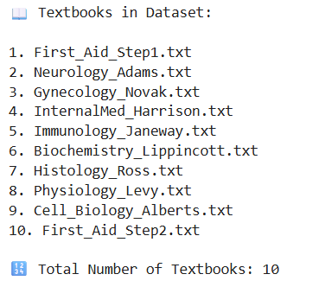
Figure 3.1: Dataset overview
The dataset used for the work is the information present in the books on medicine, which is used as the knowledge base for the Retrieval Augmented Generation (RAG) model. The dataset is taken from kaggle, and it contains information on various aspects of medicine, such as diseases, symptoms, diagnosis, etc. Each textbook contents are divided into multiple chunks
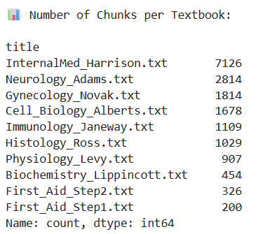
Figure 3.1.1: No.of Chunks per Textbook
Chapter 4
Preprocessing

4.1 Overview
The raw textbook content was not immediately retrievable prior to the dataset being used in the system. Preprocessing procedures were therefore used to transform the data into a format that was both structured and usable. Preprocessing's primary objective was to get the data ready so that relevant information could be effectively retrieved for any given query.

4.2 Text Cleaning
However, the medical text collected from books is not always clean and in an appropriate format. Sometimes there are extra spaces and formatting issues. Sometimes there is incomplete information in the text. Hence, cleaning of the text is done. Firstly, the text is standardized. This means that extra spaces and unwanted characters are removed from the text. This is done to ensure that the text is clean and there are no formatting issues. Sometimes special characters are removed from the text. Secondly, only meaningful information is kept in the text. Sometimes very short texts are removed because they do not contain any useful information. Moreover, the text has been maintained in a similar format to enable easy processing in further stages such as chunking and embedding. This helps in improving the quality of the data, and consequently, better similarity is obtained during retrieval. Overall, this step ensures that the data provided is clean and ready for further processing. Before using this dataset for the system, the raw data available in the form of textbooks is not directly usable for retrieval. Hence, various preprocessing steps have been taken to organize this data in a better manner for easy retrieval. The primary idea behind this is to organize the data in such a manner that information can be retrieved efficiently for a given query.

4.3 Tokenization and Text Tokenization
The text was cleaned, and then it was divided into smaller, easier-to-manage chunks. Tokenization and chunking are examples of this. The text was first broken down into individual words. This aids in comprehending the text's length. Each section's word count was also determined. This is crucial for chunk management. Due to its size, the original textbook content cannot be retrieved. Therefore, a custom function was used to divide the text into smaller sections known as chunks.
The chunking process involves the following steps:
- There are about 350 words in each chunk.
- Between successive chunks, there is a fifty-word overlap.
To guarantee the context, the overlap is required. The data may be divided between the chunks if the overlap is not preserved, which could result in improper retrieval. If the chunks are too brief or lack sufficient information, they are eliminated. This guarantees that only pertinent data is utilized. The large amount of medical data can be made usable for the retrieval system by combining the tokenization and chunking processes.

4.4 Chunking Structuring
Once the text is divided into smaller "chunks," the next step is to arrange these "chunks" in a particular format so that they can be easily used in the retrieval process. Each "chunk" is stored along with its corresponding source information. In our dataset, we have maintained two columns:
- title – represents source file name (textbook or document)
- chunk – represents actual text content extracted from source
An example is given below:
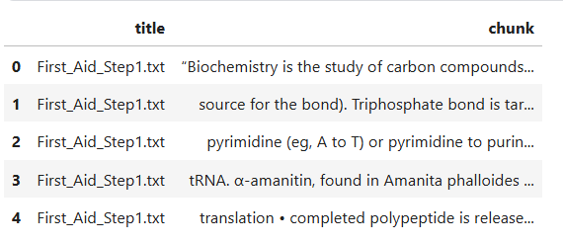
Figure 4.4: Chunking Example

Chapter 5
Proposed Methodology

5.1 Overview
The proposed system is based on the Adaptive Retrieval-Augmented Generation (RAG) framework with Knowledge Gap Detection for the retrieval of accurate and dependable medical information. The methodology is also intended to facilitate the efficient retrieval of information and the generation of appropriate answers, without the generation of answers in the absence of evidence.
The architecture of the system is illustrated below:

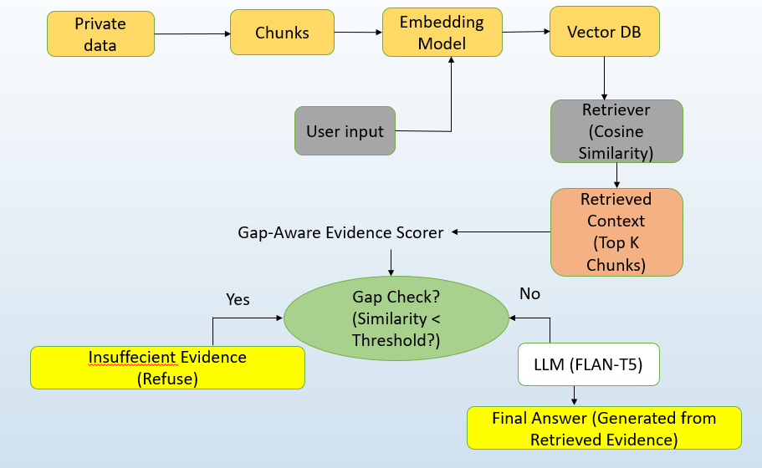
Figure 5.1: Overall Architecture
The system uses an LLM to generate the final answer after processing medical textbook data, converting it into embeddings, applying a threshold-based gap detection mechanism, and retrieving pertinent information using similarity search, as depicted in the figure.

5.2 Knowledge Base Construction
The first step in this methodology is to develop a knowledge base based on information available in medical textbooks. The raw form of this information is large and unstructured, so it is processed into smaller, more tractable pieces during this step in the preprocessing stage. Each textbook is processed and divided into multiple chunks, and each chunk includes relevant information about various medical topics, such as explanations, definitions, or descriptions of diseases and treatments. The source of this information, such as the title of the document, is also stored along with this information. This helps to retrieve only the most relevant information from the context instead of searching through the entire document, making the process more efficient and ensuring that the retrieved context is precise and useful for answering questions.

5.3 Embedding Generation
After developing the knowledge base, each text chunk is transformed into a numerical vector form using the embedding model (all-MiniLM-L6-v2). This is done to ensure that the system can compare the queries and chunks. This is because the system cannot compare the text directly. By using the embedding model, the system can transform the text into a mathematical form. This way, the system can measure the similarity between the queries and the chunks. The main reason for using the embeddings is that keyword comparison cannot be done in real-time. It has been observed that two pieces of text can have the same meaning but different keywords. For example, a query like “high blood sugar causes” and a chunk that has “diabetes mellitus” do not have common keywords. However, they are related to each other. Embeddings help capture this semantic relationship, allowing the system to identify relevant information even when exact words do not match. The embedding model represents the meaning of the text in a vector form, and similar meanings will be closer to each other in this vector space. This allows us to compare query and document chunks based on similarity metrics such as cosine similarity. In the preprocessing step, embedding is created for all the chunks of texts and stored in the vector database. Once a user query is given, at runtime, embedding is created for this query using the same model. Now, both query and document chunks will be in the same space and can be compared. Similar meanings will be closer to one another in this vector space, which is how the embedding model depicts the text's meaning. This enables us to use similarity metrics like cosine similarity to compare query and document chunks. Every text segment is given an embedding during the preprocessing stage, which is then saved in the vector database. The same model is used to create an embedding for a user query at runtime. The query and document chunks can now be compared because they are in the same area.

5.4 Vector Database Indexing (FAISS)
Following the creation of embeddings for every text segment, they must be stored in a manner that facilitates quick and effective retrieval. FAISS (Facebook AI Similarity Search) is a vector database used for this purpose. FAISS is built to efficiently conduct similarity searches and manage sizable collections of high-dimensional vectors. It would be inefficient to store each chunk in a standard database for similarity comparison because each chunk is represented as a vector. By arranging vectors so that the most similar ones can be quickly retrieved, FAISS resolves this issue.
FAISS is primarily used for its speed and scalability. Comparing a query with each chunk (brute-force search) becomes extremely slow when the dataset has a lot of chunks. To cut down on search time without sacrificing accuracy, FAISS employs optimized indexing techniques. During preprocessing, every chunk embedding is kept in the FAISS index. To swiftly identify the most pertinent chunks, the embedding of a user query is compared to this index. This greatly speeds up the retrieval process and makes it appropriate for real-time applications. FAISS's ability to facilitate effective nearest neighbor search is another benefit. It directly retrieves the top-k most similar vectors based on similarity scores rather than scanning the entire dataset. Performance and efficiency both increase as a result.
All things considered, FAISS serves as the retrieval system's foundation, facilitating quick and scalable similarity searches across the embedded medical knowledge base.

5.5 Retrieval Using Cosine Similarity
If the user has entered a query, it is converted to a query embedding using the same embedding model as the text chunks. This ensures that the query and the stored chunks are in the same space. To obtain relevant information, the query embedding is compared with all the stored chunk embeddings using cosine similarity. Cosine similarity is a method for measuring the similarity between two vectors based on the angle between the two vectors.
Cosine similarity between two vectors is given by:
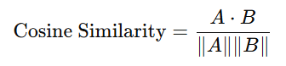
Where;
- A represents the query embedding
- B represents the chunk embedding
- $A⋅B$ is the dot product of the vectors
- ||A|| and ||B|| are the magnitudes of the vectors
The value of cosine similarity ranges from 0 to 1 in this context, where:
- A value closer to 1 indicates high similarity
- A value closer to 0 indicates low similarity

The system determines similarity scores between the query and every chunk kept in the FAISS index using this metric. The top-k most relevent chunks are chosen based on these scores. The knowledge base's most pertinent data for the specified query is represented by these top-k chunks. After that, they move on to the next phase for additional assessment. Instead of depending on precise word matching, the system retrieves semantically relevant information thanks to the use of cosine similarity. This enhances retrieval quality and enables the system to give more precise answers.

5.6 Gap-Aware Evidence Scoring
The system assesses the strength of the retrieved evidence after obtaining the top-k pertinent chunks. The system concentrates on the highest similarity score among the retrieved results rather than taking into account each chunk equally. This score indicates how well the query and the dataset's existing knowledge match. A lower similarity score denotes weak or inadequate relevance, whereas a higher score shows that the system has discovered extremely relevant information. The maximum similarity score is used because it represents the best available evidence for the particular query. The most pertinent chunk is crucial in determining whether the system has sufficient data to produce an answer, even if several are retrieved. Because not every chunk that is retrieved is equally useful, this step is crucial. While some sections might only be partially pertinent, others might offer clear and powerful information. The system guarantees that the decision is founded on the most pertinent evidence by concentrating on the highest similarity score. The similarity score obtained in this step is then used in the next stage for knowledge gap detection, where it is compared with a predefined threshold. This process helps the system decide whether the retrieved information is reliable enough to proceed with answer generation.

5.7 Gap Detection
The system assesses whether there is enough data to respond to the query after assessing the quality of the evidence that was retrieved. A threshold-based knowledge gap detection mechanism is used for this. A predetermined threshold value is compared to the similarity score from the preceding step. This cutoff serves as a decision line that distinguishes between adequate and inadequate evidence.
The following is the decision made:
- The retrieved chunks are not sufficiently relevant if the similarity score is below the cutoff. In this instance, the system recognizes a knowledge gap and refrains from producing a response.
- The system generates an answer if the similarity score is higher than or equal to the threshold, indicating the availability of pertinent information.
It can be expressed as:
If similarity >= threshold -> No Gap
If similarity < threshold -> Gap
The main of goal is to stop the system from generating inaccurate or unsupported responses when there isn't enough information in the dataset. This is especially crucial in the medical field, where false information can have detrimental effects. When a gap is found, the system returns a refusal response rather than forcing an answer. Because it doesn't deceive the user, this increases the system's dependability and credibility. All things considered, knowledge gap detection is essential to making sure the system only produces responses when there is substantial evidence to support them.

5.8 Response Generation Using LLM
The retrieved chunks are sent to the google/flan-t5-base model to produce the final response after the system verifies that there is enough evidence (i.e., no knowledge gap is found). Together with the user query, the LLM receives the retrieved context as input and uses the data to produce a response. The model employs the retrieved chunks as supporting evidence rather than depending solely on its internal knowledge. This guarantees that the generated response is based on real medical data. Because the model is informed by pertinent data from the knowledge base, the use of retrieved context aids in decreasing hallucinations. Additionally, it enhances the response's relevance and accuracy, particularly for domain-specific queries. Several retrieved chunks may be combined in this step and fed into the model. After processing this data and comprehending the context, the LLM generates a logical and significant response. The LLM is only used when there is adequate evidence, which is another crucial feature of this stage. This avoids needless computation and guarantees that the model won't produce results in the absence of trustworthy data. All things considered, the LLM serves as the last element that converts retrieved evidence into a response that is readable by humans.

Chapter 6
Experimental Results and Analysis

6.1 Threshold Analysis and Knowledge Gap Detection
Using similarity thresholding, the suggested Adaptive Retrieval-Augmented Generation system was assessed with an emphasis on knowledge gap detection. Finding an appropriate threshold value that can successfully differentiate between queries with adequate supporting evidence and those without was the primary goal of this experiment. Both in-domain (medical) and out-of-domain (non-medical) questions were included in the set of questions created for evaluation. Using cosine similarity, the system finds the top-k pertinent chunks for each query and logs the highest similarity score. The system determines whether there is a knowledge gap based on this score. Several threshold values were tested in the range of 0.20 to 0.80 with a step size of 0.05 in order to identify the ideal threshold. Standard metrics like accuracy, precision, recall, and F1-score were used to assess the system's performance for each threshold value. Figure 6.1 illustrates how these metrics vary across various thresholds.
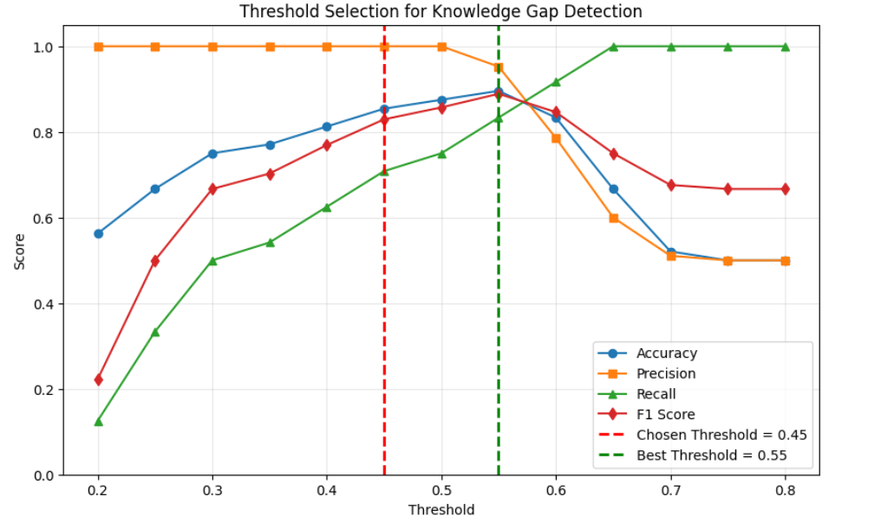
Figure 6.1: Threshold selection for knowledge gap detection showing the variation of accuracy, precision, recall, and F1-score across different threshold values. The experimentally best threshold (0.55) and the chosen stable threshold (0.45) are highlighted.
The "best" threshold value was found to be inconsistent in all cases based on the experiments. The ideal threshold shifted toward 0.50 or 0.55 in certain situations, while it appeared around 0.40 in others. Semantic overlap between medical and non-medical queries is the primary cause of this variation. For instance, despite not being strictly medical, queries about diet, exercise, or lifestyle nevertheless yield comparatively high similarity scores due to their association with health-related content. These findings led to the identification of a stable threshold range of 0.40 to 0.55. A more reliable and broadly applicable threshold was needed rather than selecting the absolute best value from a single experiment.
Certain borderline cases were noted during threshold analysis, which affected the ultimate threshold choice. For instance, if a threshold of 0.40 is applied, a question like "What is artificial intelligence? yielded a 0.4187 similarity score. The system incorrectly classifies this query as NO GAP even though it is marked as GAP (out-of-domain) because the similarity score is higher than the cutoff. This suggests that queries that are semantically related but unrelated may be able to get through the system with lower threshold values. Such questions could therefore result in the generation of inaccurate answers. A slightly higher threshold is needed to better distinguish between in-domain and out-of-domain queries in order to prevent this problem. Similarly, borderline cases were noted at higher threshold values like 0.50. For example, a question such as "What causes high blood pressure?" yielded a similarity score that was near the cutoff. In these situations, a slight difference in similarity can alter the classification outcome. When using higher threshold values, this causes the system to become less stable and more sensitive. In addition, query complexity analysis was performed by categorizing queries into simple, medium, and complex types. It was observed that each query complexity gives different similarity scores. However, this classification was used only for analysis and does not affect the core system pipeline. Overall, the experimental results show that the proposed system can be effective in detecting knowledge gaps and preventing the generation of answers based on insufficient information. The threshold value of 0.45 has provided a stable and reliable decision boundary for generating answers only when enough information is available.

6.2 Outputs
The working of the proposed system is demonstrated using sample queries. Figure 6.2 shows an example of an in-domain query where the system successfully retrieves relevant context and generates an answer. The system correctly identifies that sufficient information is available and produces a response based on the retrieved evidence. Figure 6.2.1 shows an example of an out-of-domain query where a knowledge gap is detected. In this case, the system avoids generating an answer and returns a refusal response, ensuring reliability and preventing incorrect outputs.
These examples demonstrate the effectiveness of the system in both answer generation and safe refusal.
Additionally, Kaggle Notebook with ipywidgets and Plotly was used to implement the system as an interactive demonstration interface. Real-time query input, similarity score visualization, and the display of retrieved chunks and generated answers are all made possible by this configuration, which offers a comprehensive understanding of the entire processing pipeline and system behaviour.

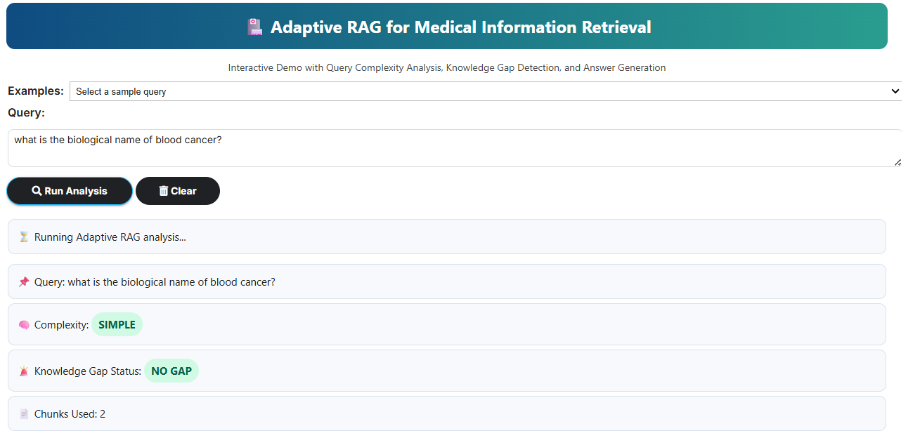
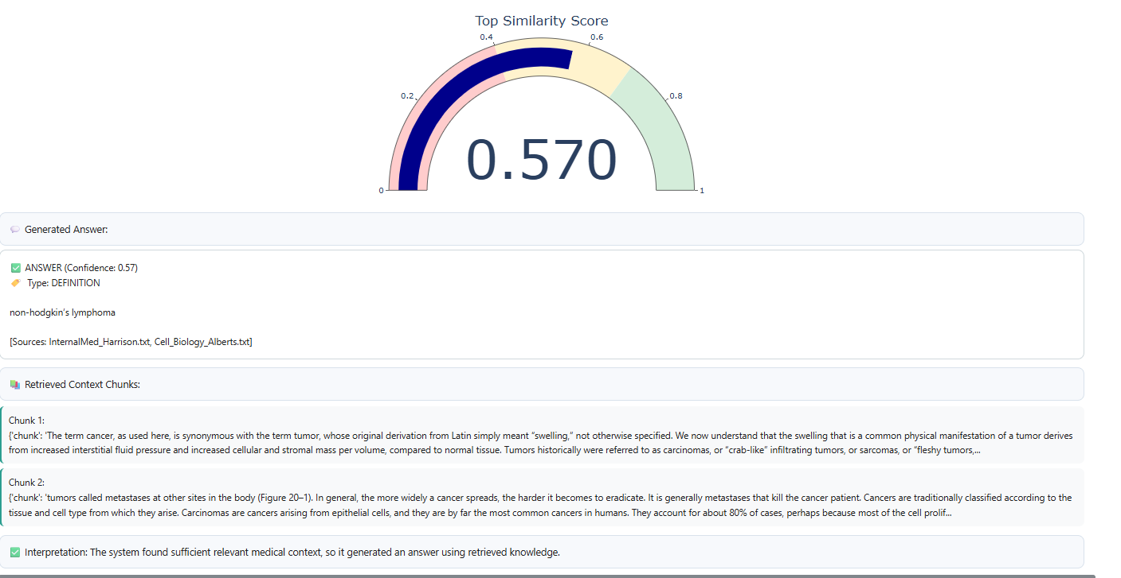
(Figure 6.2)

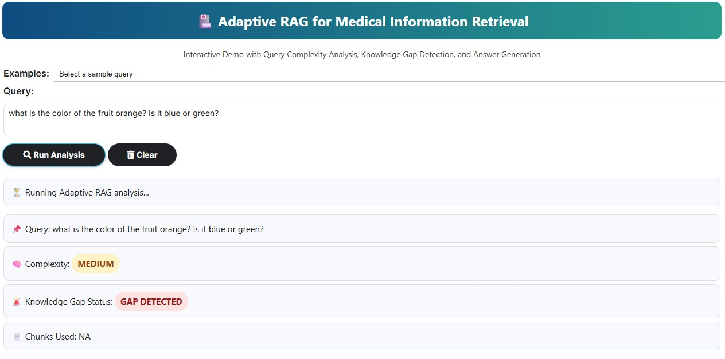
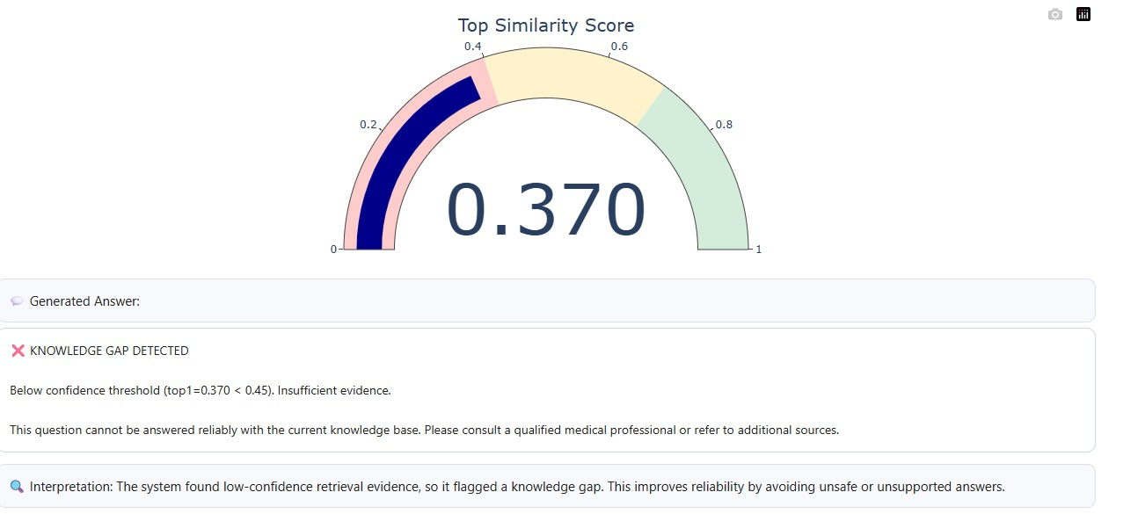
(Figure 6.2.1)

Chapter 7
Conclusion
For dependable medical information retrieval, an Adaptive Retrieval-Augmented Generation (RAG) system with knowledge gap identification was created in this work. To guarantee that responses are generated only when adequate evidence is available, the system incorporates text chunking, embedding generation, FAISS-based retrieval, and a threshold-based decision process. The construction of a knowledge gap detection system employing similarity thresholding, which aids in preventing unsupported or hallucinated replies, is one of the work's main contributions. Due to semantic overlap between medical and non-medical inquiries, it was found through experimental study that the ideal threshold value varied based on the query set. A balanced and reliable threshold of 0.45 was chosen after a consistent threshold range of 0.40 to 0.55 was found. Additionally, inquiries of different levels of complexity—simple, medium, and complex—were used to assess the system. It was discovered that while query complexity affects similarity scores, the threshold-based method is still useful for a variety of query types. The findings show that the suggested method is capable of successfully differentiating between inquiries with adequate information and those with knowledge gaps. The approach increases dependability and lowers the possibility of producing inaccurate answers by combining retrieval with controlled answer production. All things considered, the suggested method offers a workable way to create secure and reliable AI systems, particularly in delicate fields like healthcare.

References
[1] M. Klesel and H. F. Wittmann, “Retrieval-Augmented Generation (RAG),” Business & Information Systems Engineering, 2025. DOI: https://doi.org/10.1007/s12599-025-00945-3
[2] F. Ye, S. Li, Y. Zhang and L. Chen, “R²AG: Incorporating Retrieval Information into Retrieval Augmented Generation,” Findings of the Association for Computational Linguistics (EMNLP 2024), 2024. DOI: https://doi.org/10.48550/arXiv.2406.13249
[3] H. Nori, N. King, S. M. McKinney et al., “Capabilities of GPT-4 on Medical Challenge Problems,” arXiv preprint arXiv:2303.12712, 2023. Available: https://arxiv.org/abs/2303.12712
[4] G. Izacard and E. Grave, “Leveraging Passage Retrieval with Generative Models for Open Domain Question Answering,” International Conference on Learning Representations (ICLR), 2021. DOI: https://doi.org/10.48550/arXiv.2007.01282
[5] P. Lewis, E. Perez, A. Piktus et al., “Retrieval-Augmented Generation for Knowledge-Intensive NLP Tasks,” Advances in Neural Information Processing Systems (NeurIPS), 2020. DOI: https://doi.org/10.48550/arXiv.2005.11401
[6] V. Karpukhin, B. Oguz, S. Min et al., “Dense Passage Retrieval for Open-Domain Question Answering,” Proceedings of EMNLP, 2020. DOI: https://doi.org/10.18653/v1/2020.emnlp-main.550
[7] N. Reimers and I. Gurevych, “Sentence-BERT: Sentence Embeddings using Siamese BERT-Networks,” Proceedings of EMNLP, 2019. DOI: https://doi.org/10.18653/v1/D19-1410
[8] J. Johnson, M. Douze and H. Jégou, “Billion-scale Similarity Search with FAISS,” IEEE Transactions on Big Data, 2019. DOI: https://doi.org/10.1109/TBDATA.2019.2921572

